**TASK NO: 4**

## **What is ETL (Extract, Transform, Load)?**

Extract, transform, and load (ETL) is a [data integration](https://rivery.io/integrations/) methodology that extracts raw data from sources, transforms the data on a secondary processing server, and then loads the data into a target database.

ETL is used when data must be transformed to conform to the data regime of a target database. Consider an example of ETL in action. [Online Analytical Processing (OLAP)](https://olap.com/olap-definition/) data warehouses only accept relational SQL-based data structures.

With this kind of data warehouse, a protocol such as ETL ensures compliance by routing the extracted data to a processing server, and then transforming the non-conforming data into SQL-based data.

The extracted data only moves from the processing server to the data warehouse once it has been successfully transformed.

**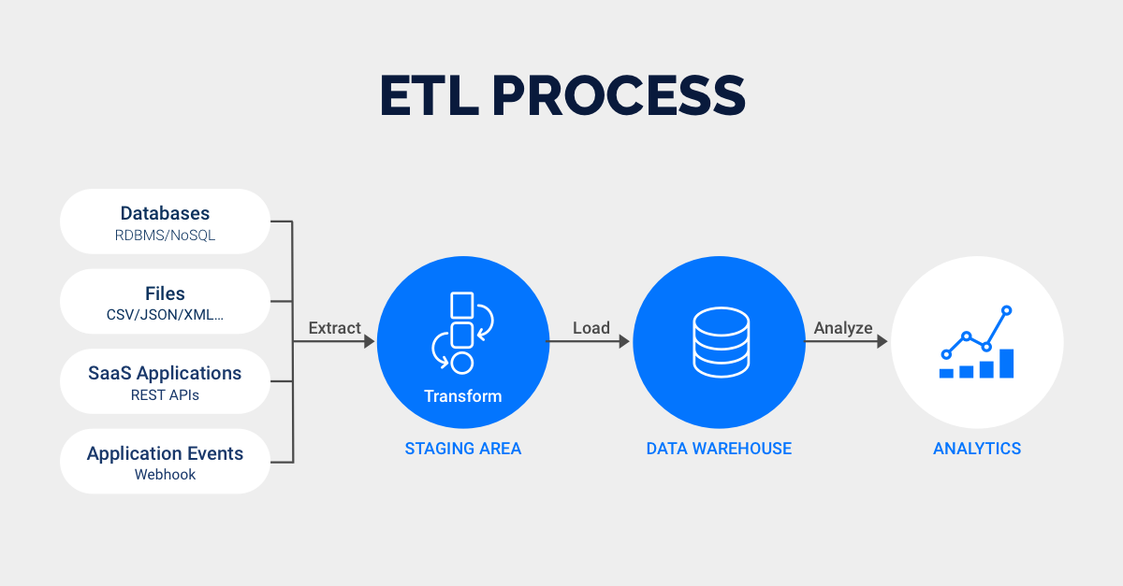**

## **What Is ELT (Extract, Load, Transform)?**

ELT loads raw data directly into a target data warehouse, instead of moving it to a processing server for transformation.

With ELT data pipeline, [data cleansing](https://rivery.io/data-management-glossary/data-cleansing/), enrichment, and [data transformation](https://rivery.io/product/data-transformation/) all occur inside the data warehouse itself. Raw data is stored indefinitely in the data warehouse, allowing for multiple transformations.

ELT is a relatively new development, made possible by the invention of scalable cloud-based data warehouses.

Cloud data warehouses such as [Snowflake](https://www.snowflake.com/), [Amazon Redshift](https://aws.amazon.com/redshift/), [Google Big Query](https://cloud.google.com/bigquery/), and [Microsoft Azure](https://azure.microsoft.com/en-us/) all have the digital infrastructure, in terms of storage and processing power, to facilitate raw data repositories and in-app transformations.

Although ELT data pipeline is not used universally, the method is becoming more popular as companies adopt cloud infrastructure.

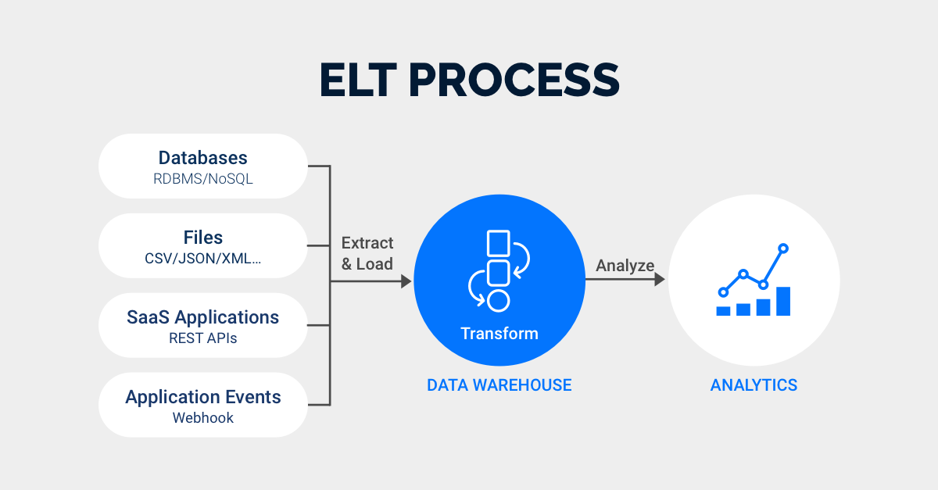

**What is three-tier Architecture?**

Three-tier architecture is a well-established software application architecture that organizes applications into three logical and physical computing tiers:

The presentation tier, or user interface.

The application tier, where data is processed.

The data tier, where the data associated with the application is stored and managed.

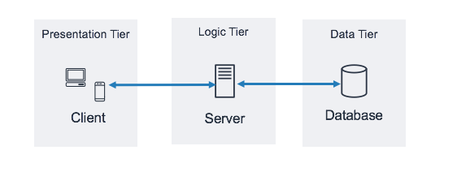

The chief benefit of three-tier architecture is that because each tier runs on its own infrastructure, each tier can be developed simultaneously by a separate development team, and can be updated or scaled as needed without impacting the other tiers.

For decades three-tier architecture was the prevailing architecture for client-server applications. Today, most three-tier applications are targets for [modernization](https://www.ibm.com/topics/application-modernization), using [cloud-native](https://www.ibm.com/topics/cloud-native) technologies such as [containers](https://www.ibm.com/topics/containers) and [microservices](https://www.ibm.com/topics/microservices" \o "microservices" \t "_blank), and for [migration](https://www.ibm.com/topics/application-migration) to the cloud.

## **What are ELT Tools?**

Extract, Load, Transform (ETL) tools are software programs designed to extract data from various sources, load that data into a target system, and transform the data into a format suitable for analysis or other purposes.

ETL tools are commonly used in [data warehousing](https://www.simplilearn.com/benefits-of-data-warehousing-article) and [business intelligence](https://www.simplilearn.com/what-is-business-intelligence-article) applications to move data from operational systems into a data warehouse or [data mart](https://www.simplilearn.com/what-is-data-mart-article), where it can be stored and analyzed.

**Top ELT Tools:**

### Hevo Data:

### Hevo Data is a cloud-based data integration platform allowing organizations to collect, clean, and analyze data from various sources. It is designed to be easy to use and requires no coding, making it suitable for users needing more technical expertise

### Luigi:

Luigi is an open-source [Python](https://www.simplilearn.com/tutorials/python-tutorial) framework for building data pipelines. It is designed to be easy to use. You can use it to manage the complete data processing lifecycle, from extracting data from various sources to loading it to a destination.

### 

### Blendo:

### Blendo is a cloud-based data integration platform that allows organizations to collect, clean, and analyze data from various sources. It is designed to be easy to use and set up in just a few minutes, making it suitable for users needing more technical expertise.